ALEX LEWANDOWSKI

PROJECT PORTFOLIO · MECHATRONICS ENGINEERING, UNIVERSITY OF WATERLOO
Portfolio: alexlewandowski.ca GitHub: github.com/Lew-Alex LinkedIn: linkedin.com/in/alex-lewandowski
647-330-5877 alewando@uwaterloo.ca Full write-ups, photos and CAD are on the portfolio site.

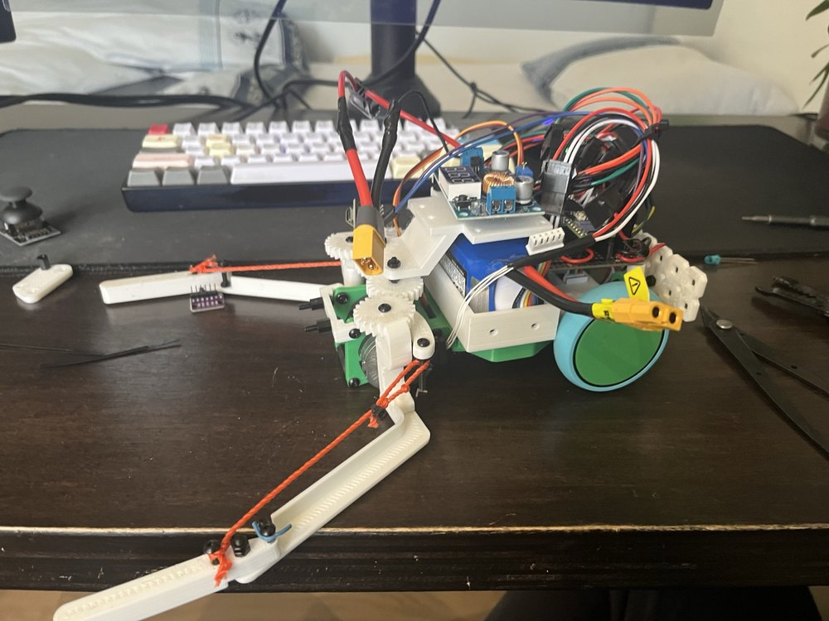 | 01 Autonomous Robot, World Robot Olympiad Oct 2025 to May 2026  Autonomous robot for the WRO RoboMission challenge. Qualified for the California Invitational Open after Nationals, where it was the only entry using both pneumatics and custom-designed electronics.  - Built a Monte Carlo particle filter for localization, fusing wheel odometry, IMU heading and two downward-facing colour sensors reading the floor against a pre-mapped grayscale image of the field, correcting drift as the robot moved.  - Prototyped the filter and field map in Python, visualizing particle convergence, then ported the logic to C++ on the embedded target and tuned resampling and weighting against real sensor noise.  - Split compute across two processors, one running sensor fusion, localization and motor control, the other dedicated to a 9-axis IMU relaying heading over a custom COBS-framed serial link.  - Integrated a camera module for vision-based detection of field elements, and designed and 3D printed the chassis in CAD to fit the competition size limit.  Tools: C++, Python, I2C, sensor fusion, CAD, 3D printing  Write-up: alexlewandowski.ca/projects/wro-robot Code: github.com/Lew-Alex/WRO-PiThons-2026

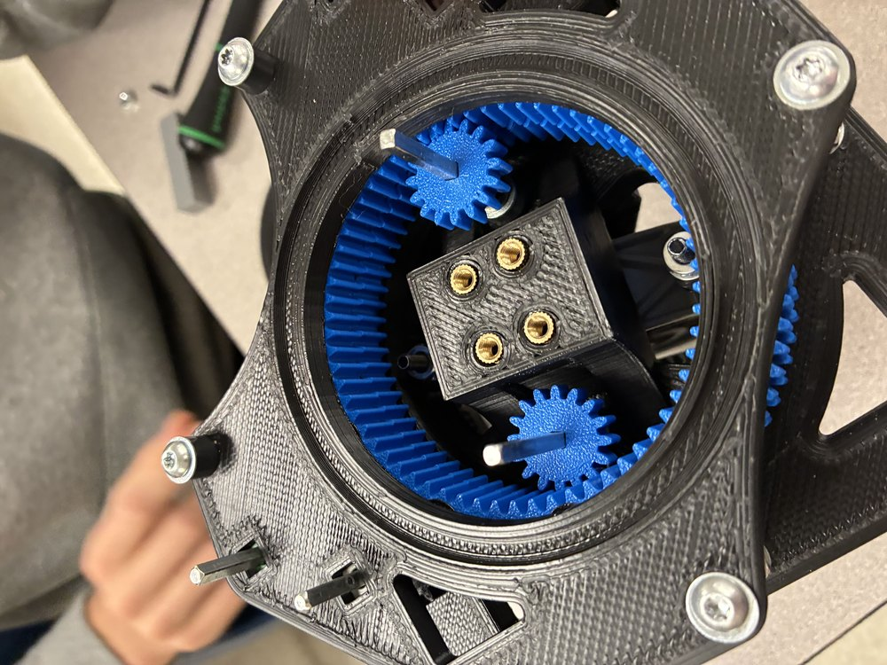 | 02 Differential Swerve Drivetrain Sep 2025 to Dec 2025  A custom differential swerve drivetrain for VEX V5. Each module uses two motors that drive and steer at once, the difference in motor speed swivelling the wheel. Taken through two iterations, from a single working module to a full four-wheel chassis.  - Designed each module as a planetary system using two 84:64 ring gears and a pair of 40:20 bevel gears so both motors contribute to drive and steer.  - Calculated gear ratios in Fusion 360 for a 6.5 ft/s target and measured 6.2 ft/s on the finished module using slow-motion video.  - Built a custom thrust bearing from ten 4.5 mm steel balls in a 3D printed cage after no standard bearing fit the space.  - Ran gear-skip, stall and structural tests under load, found the C-channels bending under top-only support, and fixed it in the second iteration with printed triangle braces.  - Added a quadrature encoder per module for closed-loop feedback and wrote a vector class handling Cartesian and polar coordinates to turn joystick input into a target speed and angle.  Tools: Fusion 360, C++ (PROS), gear design, load testing, 3D printing  Write-up: alexlewandowski.ca/projects/differential-swerve-drive Code: github.com/Lew-Alex/Differential-Swerve-Drive

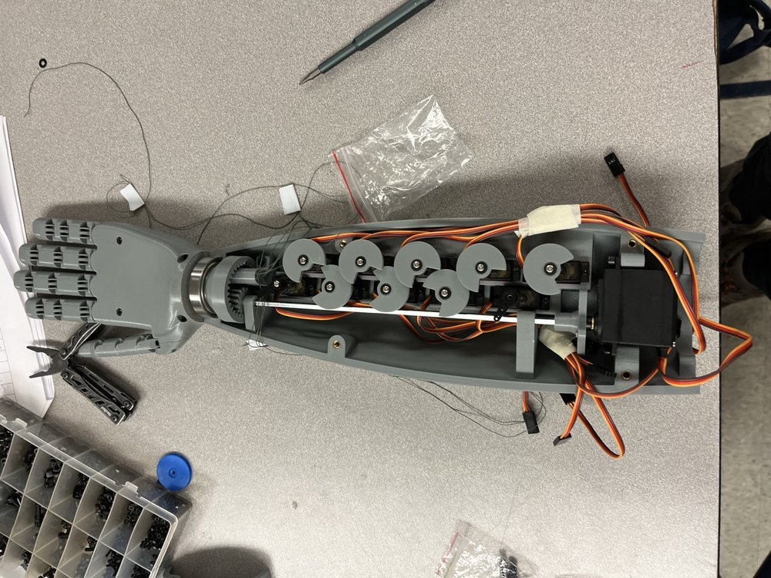 | 03 Dexterous Robotic Hand Nov 2025 to Jan 2026  A five-fingered robotic hand with a rotating wrist and elbow that grips a 250 g spherical object, with all actuation routed internally and no external wiring.  - Designed a string push-pull finger mechanism routed through full-length slits rather than circular holes, removing the friction that stalled earlier prototypes and letting the string self-align.  - Used elastic return tension so each finger needs only one actuator, and produced horizontal tilt by pulling a finger's two strings asymmetrically.  - Geared wrist rotation through a drive gear turning a ring gear on a 45 mm bearing, holding rotation within a ±45° range.  - Programmed all 11 servos on a Raspberry Pi Pico in bare-metal C, configuring PWM slices and channels manually and using structs and enums in place of classes.  - Diagnosed a current-limited power fault that stalled servos beyond four fingers at once, and restored clamping force lost to print sag with a printed gasket.  - Scored concepts in a decision matrix on constructability, function, efficiency and reliability before committing to the final design.  Tools: CAD, 3D printing, mechanism and gear design, bare-metal C  Write-up: alexlewandowski.ca/projects/robotic-hand

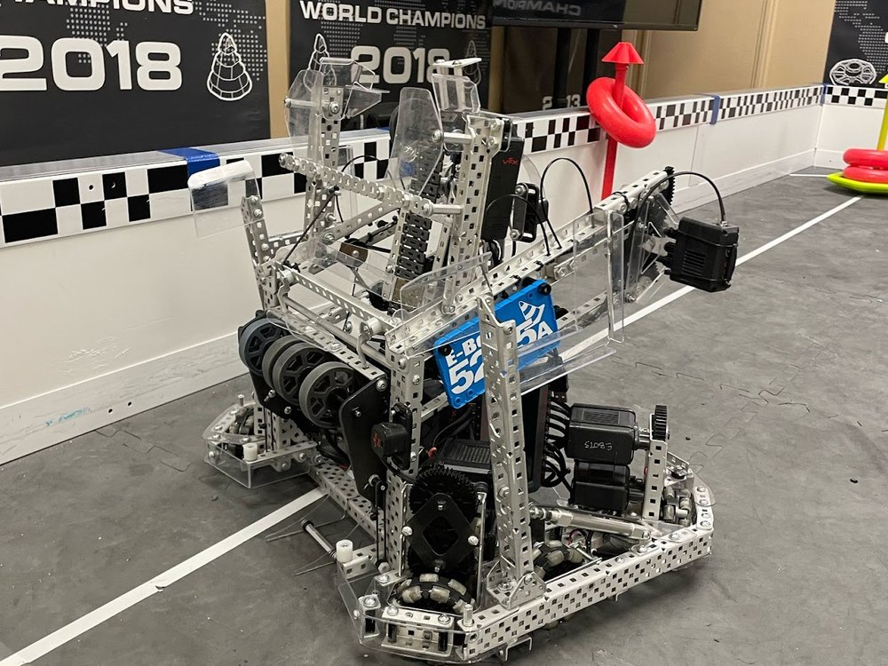 | 04 VEX Robotics Team 5225A Competition Code Jun 2022 to Jun 2026  The C++ autonomous and driver-control stack for a team that won the Excellence Award at 2025 Ontario Provincials as the top team in the province, placed 4th of more than 10,000 teams worldwide in Autonomous Skills at VEX Worlds, and took the Think Award in 2024 and 2026 for code quality and documentation.  - Built an odometry system fusing gyroscope, encoder-wheel and distance-sensor data to track position to ±0.02 m.  - Designed closed-loop PID and feedforward velocity controllers driving real-time autonomous motion.  - Applied kinematics and inverse kinematics for arm positioning during game-element manipulation.  - Structured the codebase around state machines coordinating subsystems across autonomous and driver phases, and ran code reviews for a three-person programming subteam.  Tools: C++, PROS, OkapiLib, control theory, Git  Code: github.com/Lew-Alex/5225A-2024-2025 Details: alexlewandowski.ca/experience

05 Tetris AI Personal project
A neural network evolved with NEAT that plays real, on-screen Tetris, reading the board through OpenCV screen capture rather than a simulated game state.
- Built the vision layer in OpenCV to capture and parse the live board, then fed the extracted state to the network.
- Trained the controller with NEAT neuroevolution and evaluated it against the running game.
Tools: Python, OpenCV, NEAT
Code: github.com/Lew-Alex/Tetris-AI

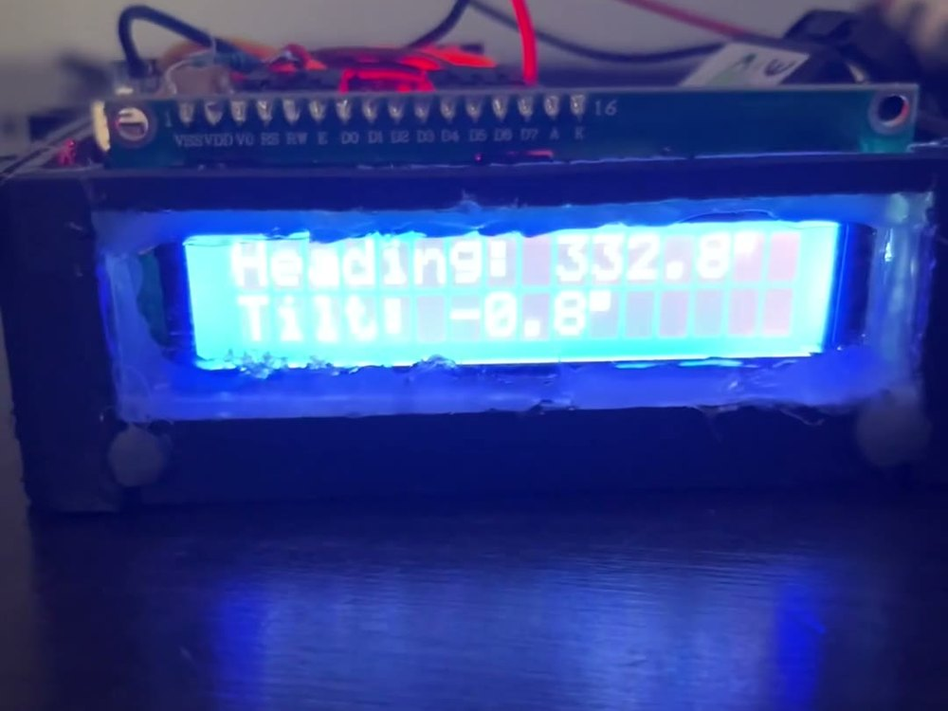 | 06 Sailing Electronic Compass Personal project  A handheld electronic compass for sailing navigation, displaying live heading and tilt on an LCD from a custom-built enclosure.  - Reads orientation from an IMU and drives a character LCD, showing heading and tilt to one decimal place.  - Built and housed the electronics myself for use on the water. Written in C++.  Tools: C++, embedded electronics, IMU, LCD  Code: github.com/Lew-Alex/sailing_compass Write-up: alexlewandowski.ca/projects/sailing-compass

Other repositories: ReversiAI (minimax search) CCC_Solutions (Canadian Computing Competition)

